**Problem statement: -**

-Use the inbuilt dataset ‘titanic’ as used in the above problem. Plot a box for distribution of age with respect to each gender along with the information about whether they survived or not (column names-sex and age)

-Write observation on the inference from the above statistic

**Observation:-**

Plotting the data using plot box to display the information of peoples who survived on the ‘titanic’ with respect to their age and gender.

**PROCEDURE:**

1. Boxplots are created in R by using the boxplot() function.

2. The basic syntax to create a boxplot in R is − boxplot(x, data, notch, varwidth, names, main)

3. Following is the description of the parameters used –

a. x is a vector or a formula.

b. data is the data frame.

c. notch is a logical value. Set as TRUE to draw a notch.

d. Var width is a logical value. Set as true to draw width of the box proportionate to the sample size.

e. names are the group labels which will be printed under each boxplot.

f. main is used to give a title to the graph.

**PROGRAM:**

# Give the chart file a name. png(file = "boxplot.png")

# Plot the chart. boxplot(mpg ~ cyl, data = mtcars, xlab = "Number of Cylinders", ylab = "Miles Per Gallon", main = "Mileage Data")

# Save the file.

dev.off()

**Output:-**

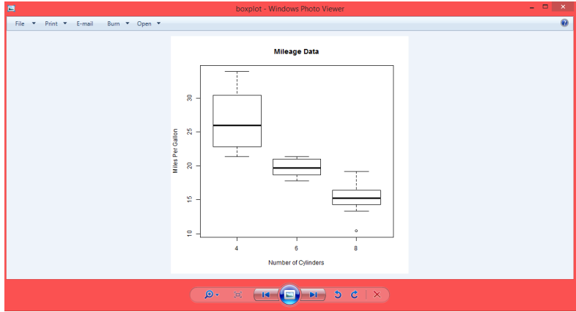

**Result:-**

Thus the data is visualized using plotty framework.